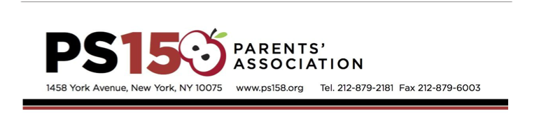

tax ID # 237025684

October 2018

Dear Friend:

PS 158 is a vibrant public school on the Upper East Side of Manhattan with 800 students, pre-K to 5th grade. To help offset DOE budget cuts, this school maintains its standard of excellence with the ongoing support of the community and the active support of the parent body. The PS 158 Parents’ Association has kicked off its annual fundraising auctions for 2018-2019.

We are asking for your generosity and support by providing products, services or monetary donations. By making a tax-deductible donation, you will gain valuable exposure at our auction events. Your business or service will be publicized in all auction materials.

The auctions and contribution deadlines (to be included in all materials) are:
- Winter Online Auction - Deadline November 1st
- Live Auction Event and Post-Event Auction – Deadline March 2nd
The Live Auction Event will be held on March 23rd. Last year’s live benefit was attended by nearly 400 local parents, community supporters, political leaders and school educators. Online auction shoppers include both local residents and participants from across the country.

These funds support a wide range of programs including arts & cultural enrichment programs, recess sports program and coaches, books and technology for the classroom, kindergarten assistant teachers, and teacher training and development. Your support will make a real difference to our students!

Please return the enclosed donation form by ​email to ​158donations@gmail.com​, ​by fax to 212-879-6003, or by mail to:

PS 158 Parents’ Association
1458 York Avenue, Room 105
New York, NY 10075

OR, you may complete your donation form online by clicking here.

On behalf of the entire PS 158 school community, thank you for your consideration and support.

Sincerely,

The Auction Chairs

